Physical weathering
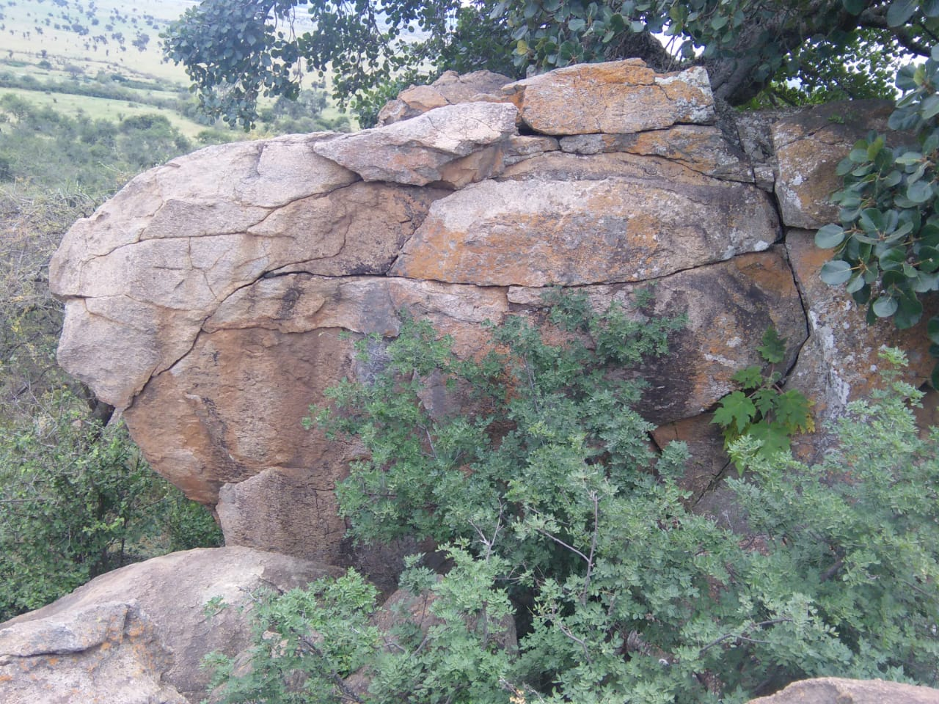
When rock’s conditions are affected by the area of the climate they react as a form of physical weathering. In the above example, the rock is subjected to weathering physically through harsh climatic conditions. The contraction due to very low temperatures at night and subsequent expansion may result to the process due to unequal expansion and contraction. Additionally, freeze-thaw action may significantly contribute to the weathering of the rock.
Chemical Weathering
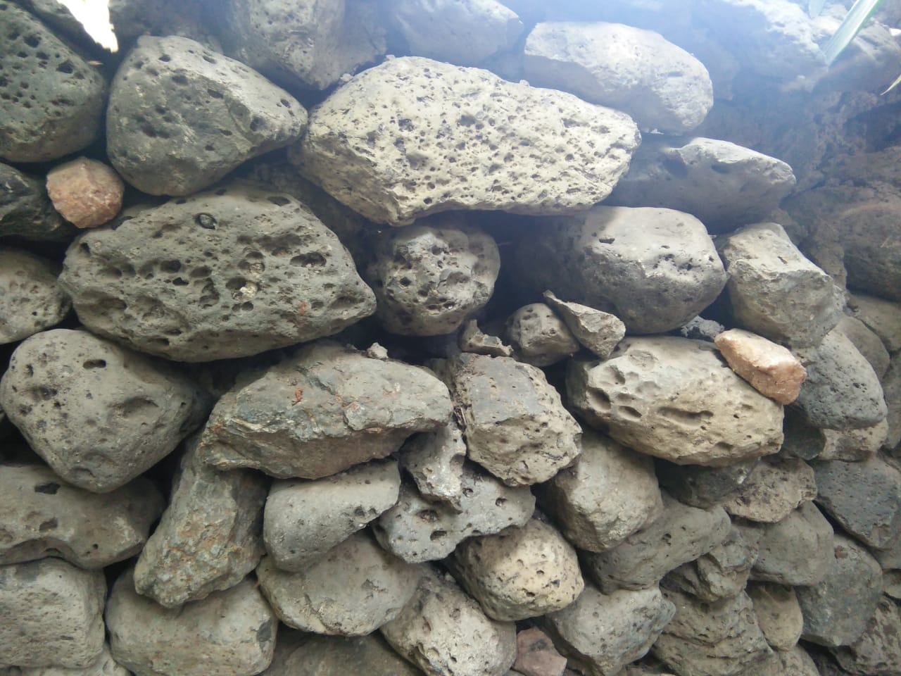

In this example, the reaction as a result of chemical weathering has made the rock to have some cave holes. The chemical reaction due to weather breaks down molecules on atoms. Moisture and heat are present in nature for this reaction to occur. With every element present, reactions like acidification, hydrolysis, and oxidation occur
Biological weathering
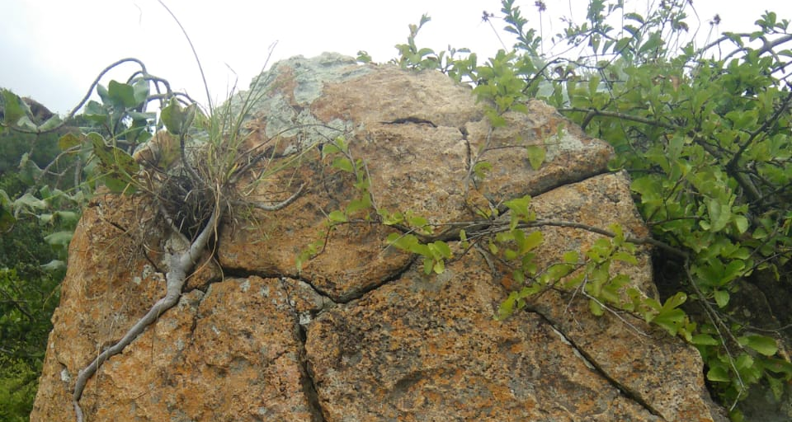
Biological weathering occurs as a result of animals and plants. In this example, a tree has grown in the middle of the rock. In biological weathering, the breakdown of minerals through lichens or fungi affect the landscape. The lichens live on the rock so most often they are found by oceans where the air is humid and cool. Other bacteria can take the form of aerobic or anaerobic and thus capable of living in conditions such as in between rocks. Other aerobic bacteria can oxidize mineral, especially like pyrite resulting in degradation of the rock, staining, and change in color.

